

BRAES HIGH SCHOOL
ACTIVITIES DAY
24 June 2026
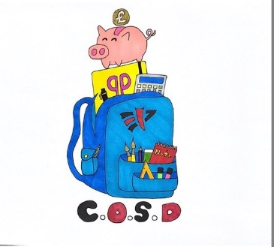
Article 28 (right to education) Every child has the right to an education
Article 29 (goals of education) Education must develop every child’s personality, talents and abilities to the full.
Article 31 (leisure, play and culture) Every child has the right to relax, play and take part in a wide range of cultural and artistic activities
Activities Day 2026
Please read this information carefully
Activities Day this year will be held on Wednesday the 24th of June. Pupils will have the opportunity to choose either one activity from the ‘external activities’, followed by one reserve activity; OR one from the ‘in-school activities’ listed, followed by reserve choice of activity.
Pupils will complete an online google form that will be sent out to all parents/carers on Wednesday the 1st of April 2026 at 5.30pm. PLACES WILL NOT BE CONFIRMED FOR ACTIVITIES UNTIL YOU ARE NOTIFIED VIA EMAIL BY THE SCHOOL OFFICE.
We want every pupil to be able to participate in Activities Day, and enjoy their day. Therefore, there is funding available to support with the activities if required, so please contact the school office if you require more information.
Please note that payment is NOT due until the activity place has been confirmed via email by the school office. Submission of the choice form DOES NOT guarantee a place and, even once payment is made, the Senior Management Team reserve the right to cancel a pupils’ booking and refund their money (where possible) if behaviour in the lead up to activities day is not acceptable. Other reasons for a refund may include cancellation of an activity, a reduction in cost of an activity, or a necessary reduction of numbers attending an activity due to venue or transport restrictions. We understand that circumstances may arise which could result in you removing your child from the trip. However, the Council incurs costs from the time your child’s booking is confirmed with the activity company. All aspects of this trip, including price and transport, are based on all confirmed pupils attending; therefore, we cannot reimburse you for any monies paid unless the place on our trip can be filled by another pupil. If we cannot fill the place, you will also be liable to pay the outstanding balance of the trip if the school incurs costs as a result of your child’s withdrawal.
Pupils will be issued with written confirmation of their place shortly after we return from the Easter break, along with the payment due and the methods of payment available to them. They will then have until Friday the 8th of May to make their payment and secure their spot on the trip.
The preferred method of payment is by online payment which you can access via www.ipayimpact.co.uk, but we will also accept card payments, cash or cheques (payable to Falkirk Council), via the school office. After the 8th of May, pupils could lose the right to their allocated place and we will transfer the place to pupils on the waiting list. Please contact the school if you have any concerns regarding payment before this date.
Any general questions regarding this event should be directed to Mr B Smith, Faculty Head (01324 719551 or brendan.smith@education.falkirk.sch.uk).

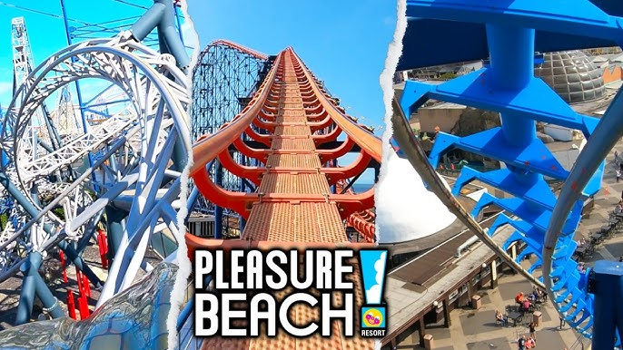

PLEASURE BEACH
Cost: £65
Trip Leaders: Miss K Graham / Mr A Young
Maximum Number: 140 S3-S5 pupils.
Open to: All S4-S5 pupils with a good behaviour record. S3 Pupils can select this as a reserve activity and if there are places remaining, they will be offered them.
Details:
Get ready for an unforgettable day of thrills, laughter, and seaside fun on our upcoming school trip to Blackpool Pleasure Beach! 🎢🌊

Students will have the chance to experience one of the UK’s most iconic amusement parks, packed with exciting roller coasters, family rides, and classic attractions. From the twists and turns of the legendary wooden coaster, the The Big One, to fun-filled attractions suitable for everyone, there’s something to suit all levels of bravery!

Pupils will leave the school around 5.30am followed by a 10pm return to school on Wednesday the 24th of June!
For more details visit:
https://www.blackpoolpleasurebeach.com

BLAIR DRUMMOND SAFARI PARK

Cost: £20
Trip Leaders: Miss K Mackie & Biology Department
Maximum Number: 40 Pupils
Open to: All pupils with a good behaviour record
Details:
Pupils will have the change to do the tour of the park including the wild animal reserves, take the boat trip, watch the Sea Lion show, experience the pet farm, tackle the ‘flying fox’, see the Lemur Land and Birds of Prey, ride the giant Astra-slide and many more exciting activities.
Pupils should bring a packed lunch or money to purchase lunch at the park.
For more details visit
http://www.blairdrummond.com/



XTREME KARTING
Cost: £45
Trip Leader: Mr A Grant
Maximum Number: 40 Pupils
Open to: Pupils who will be 12 years or older on 24 June 2026 with a good behaviour record.
Details: Leaving school at 9am and return at around 2pm. Pupils with travel by coach.
Pupils will attend Xtreme Karting, Larbert where they will get the chance to compete in multiple laps of the indoor circuit, against other pupils on a competition circuit. They will have sessions on the track, competing with other pupils. Pupils MUST be 12 years old or older at the date of Activities Day to take part.
Pupils should bring a packed lunch and money for snacks, if they wish to buy them.

For more details visit
https://xtremekarting.co.uk/


Cost - £35
Lead Teacher – Miss L Kinnear (for more details visit Golf, Party Venue, Sports Bar & Restaurant | Topgolf Glasgow)
Maximum Number – 42 pupils
Open to: All pupils with a good behaviour record.
Top Golf Glasgow is an entertainment experience featuring a high-tech golf game that everyone can enjoy. Over 3 floors there are 70 climate controlled all weather hitting bays with HDTVs in every bay.
Using complimentary clubs you will take aim at the giant outfield targets and the high-tech balls will score themselves.
Once you settle into your climate-controlled bay, a bay host will get you up to speed, and help you set up the game you choose.
Two hours of TopGolf game play with 6 players per bay.
Special menu served in a brioche roll together with seasoned house fries, and a choice of soft drink. Choose from:
  - Signature Beef Smash Burger
  - Veggie Burger
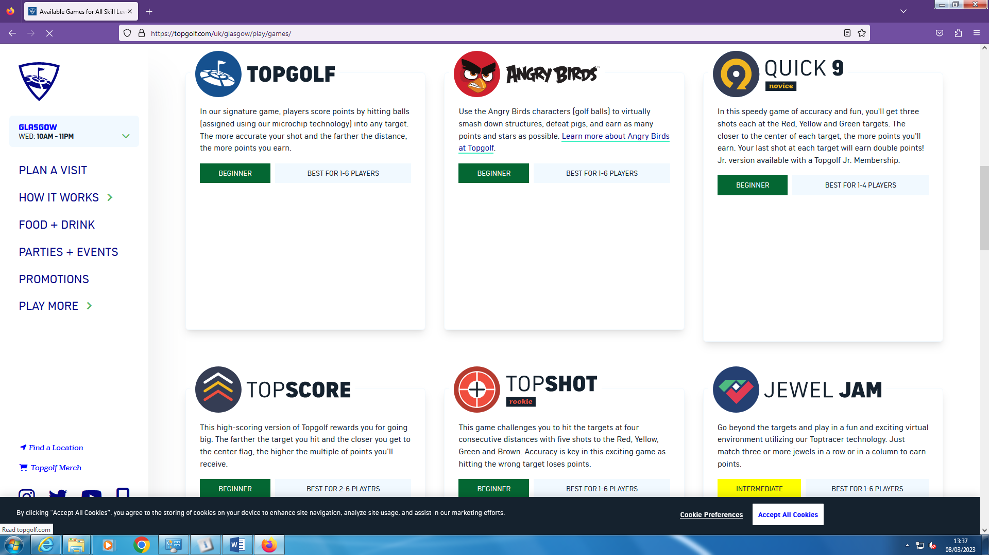
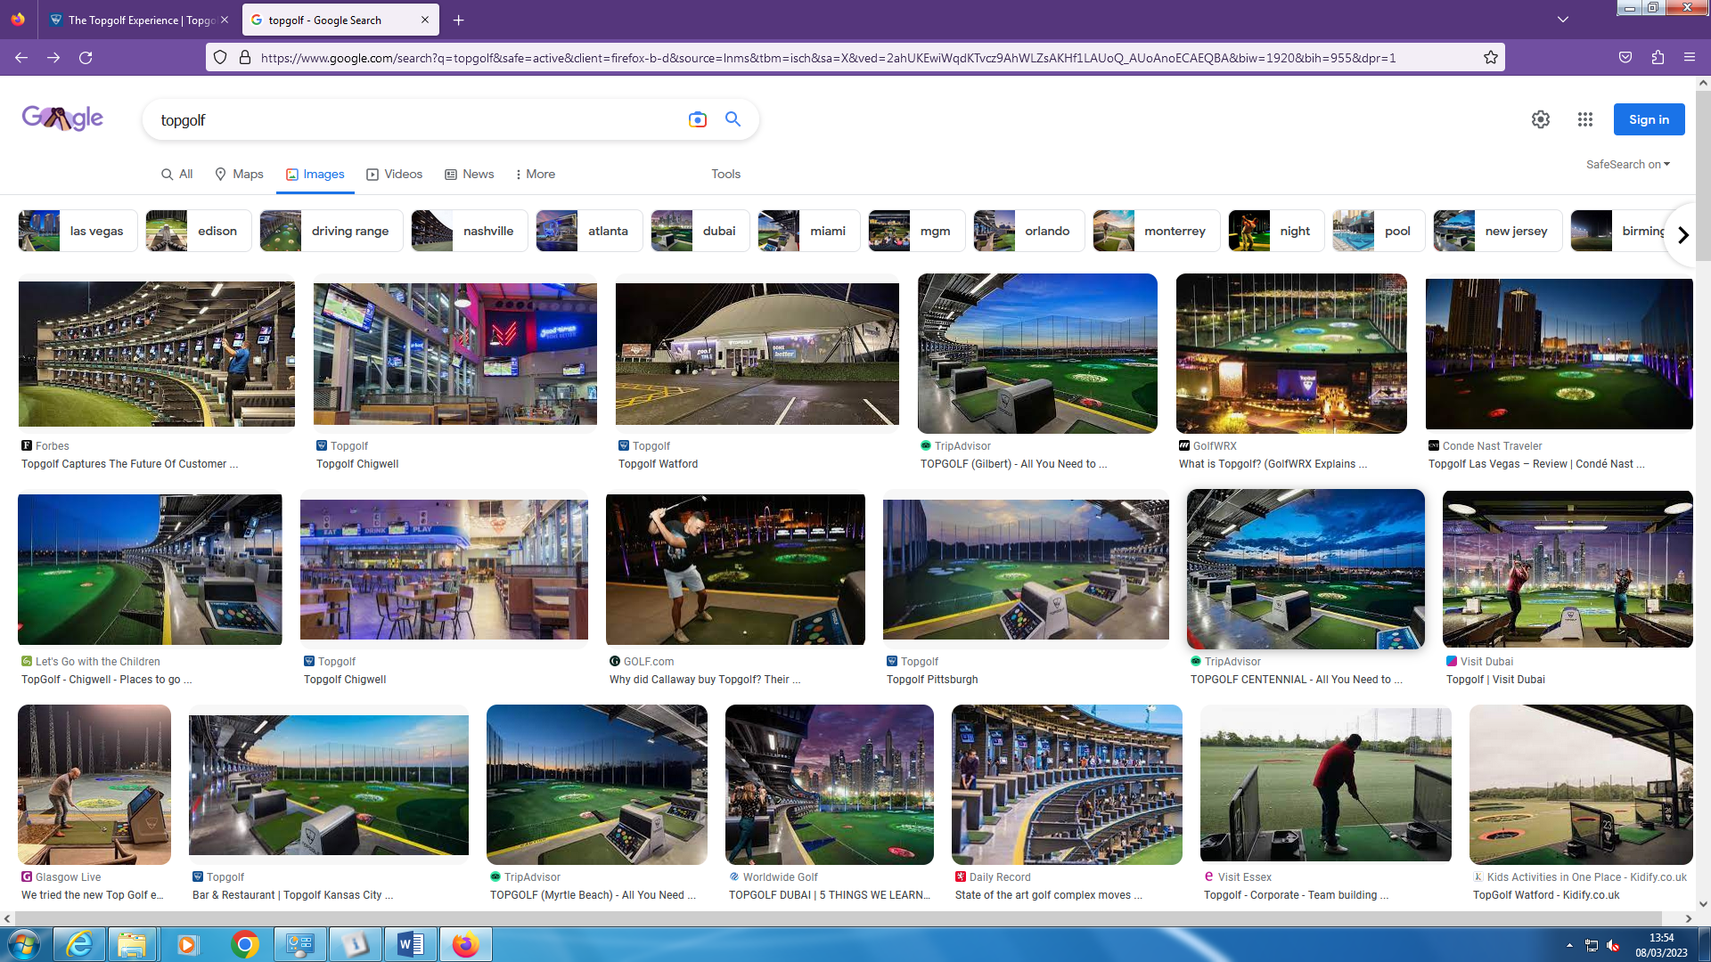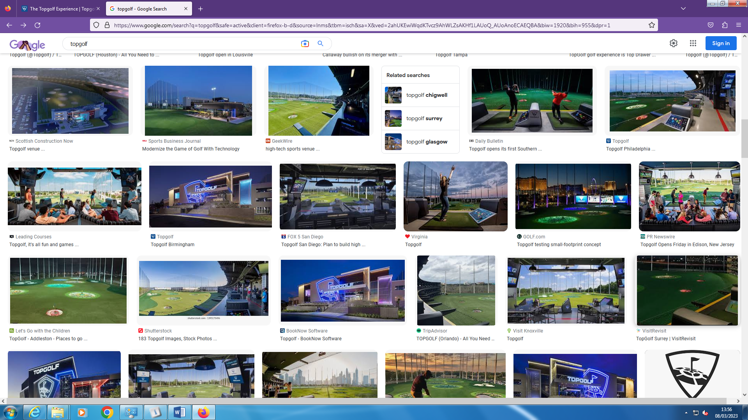
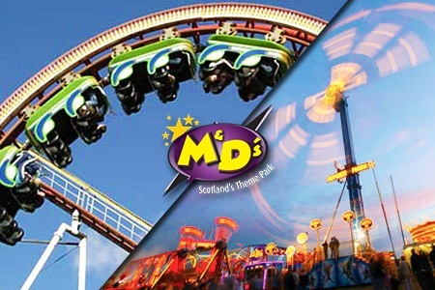

M & D’s
Cost: £30
Trip Leaders: Mrs R Cameron / Ms T Jennings
Maximum Number: 46 Pupils
Open to: All pupils with a good behaviour record. S1-S3 Pupils will be given priority due to Pleasure Beach restrictions.
Details:
· Ensure you wear suitable clothing for the weather.
· Bring a packed lunch or there are options in the park for you to buy lunch.
· Take care of any money taken and mobile phones whilst on rides.
· Additional activities i.e. crazy golf costs extra – please check website Scotland's Theme Park (scotlandsthemepark.com) .
· Bags are not to be stored on the bus as there is no access during the trip. So please take care of your property.
· Any medication you need – please take with you. If there is anything which we should be aware of please let us know.
· No rubbish to be left on the bus. Black bags will be provided.
· Be courteous at all times as you normally do at school.
· Pupils will be taken to the M&D’s theme park by coach leaving the school at 9.30am .
· We arrive back at the school at approx. 4.15 - 4.30pm for you to be collected by your parent/guardian. If you stay within walking distance then you can make your own way home.
Most of all, this is a great day out, so enjoy yourself!

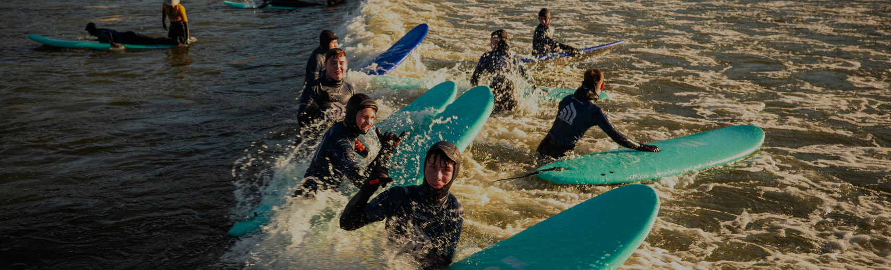
Cost: £45
Trip Leaders: Miss E Reid
Maximum Number: 45 Pupils
Open to: All pupils with a good behaviour record
Details:
Lost Shore Surf Resort is Europe’s largest inland surfing destination based at Newbridge near Edinburgh.
Whether you’re a first-time surfer, want to hone your skills or catch the perfect barrel.
All you will need are towels and swimsuits – they take care of the rest, providing top-notch surfboards and wetsuits.
The day features a 90-minute coached surf session in the bay coached by one of the ISA qualified instructors.
The state-of-the-art technology will allow them to adjust the size, power, and shape of the waves at the push of a button.
Get ready for an unforgettable experience filled with waves, fun, and learning.
Please make sure you bring your sun tan lotion if it is a sunny day!
Food will be included - choose between Chicken strips, Nachos or Pizza, and a drink.
For more details visit:
Lost Shore Surf Resort | Edinburgh's Surf & Hotel Getaway

CROSSFIT 1298 GYM VISIT
Cost: £14
Trip Leaders: Mr Docherty & Miss Hillcoat
Maximum Number: 30 Pupils
Open to: All pupils with a good behaviour record
Challenge Yourself: Activities Day at CrossFit 1298!
Are you ready to level up? This Activities Day, we’re heading to CrossFit 1298 in Falkirk for a day of power, technique, and teamwork.
This isn't just a workout—it’s an inside look at elite gym culture. You’ll spend the morning working with expert coaches to master pro gym techniques and test out world-class equipment. Once you've found your rhythm, it’s game on! We’ll be finishing the day with an epic Mini CrossFit Competition to see who can push their limits.
The Essentials:
- Wear: Full PE kit / Comfortable gym gear and trainers.
- Bring: A water bottle and a nutritious packed lunch.
- Vibe: Bring your energy—no experience required!
For more details see Mr Docherty/Miss Hillcoat.



MOVIE MAKING
Cost: FREE
Trip Leader: Ms E Taylor
Open to: All pupils with a good behaviour record
Maximum Number: 20 Pupils
Details:
Interested in film making?
Come make a movie in a day. We will devise, script, perform and premiere a film in 6 periods! Whether you’re interested in being in front or behind the camera this activity will have a challenge for you. No previous experience necessary just enthusiasm and a can-do attitude!

For more details see Ms E Taylor.

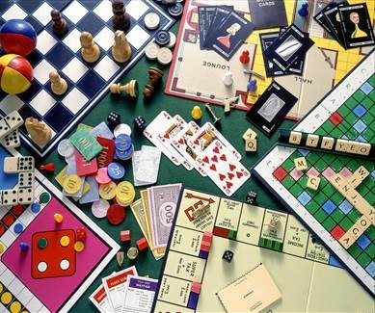

BOARD GAMES
Cost: Free
Maximum Number: 20 Pupils
Open to: All pupils with a good behaviour record
Details:
Come along to the Library Board Game Café for a day of board games! Enjoy a selection of games that will be available such as Monopoly, Cluedo, Uno, Bananagrams and Exploding Kittens.

Pupils are invited to bring in their own boardgames on the day as well!

For more details see Mr B Smith
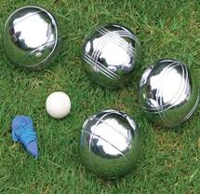

FRENCH BOULES AND LANGUAGES BADGE
Cost: Free
Trip Leader: Mrs L Murray & Modern Languages Department
Maximum Number: 20 pupils
Open to: All pupils with a good behaviour record
Details:
“Come along and join the Modern Languages Department and take part in some games of French Boules (hopefully outside in the sun!) followed by some badge making.”

For more details see Mrs Murray.


CRAFTY CORNER
Cost: FREE
Trip Leader: Mrs C Maley
Maximum Number: 30 Pupils
Open to: All pupils with a good behaviour record
Details:

- Half day activity.
- Completely free activity.
- Come along and spend a morning crafting your own project or try something new. Crochet, knitting, cross stitch, sewing, mosaic, drawing, painting or even origami. Feel free to bring along any projects you’ve started at home that you’d like to finish or even try to teach me something new . . .

For more details see Mrs Maley.



MEDIA & FILM ACTIVITY
Cost: Free
Trip Leader: Mr M Rooney & English Department
Maximum Number: 20
Open to: All pupils with a good behaviour record
Details: Are you interested in films and want to know more about the techniques used to create them? Come and join us for a day dedicated to the art of film and media. Throughout the day we will be working on the following:
- Learning about film techniques
- Watching and analysing a classic film
- Creating a storyboard for an original film idea

For more details see Mr M Rooney.

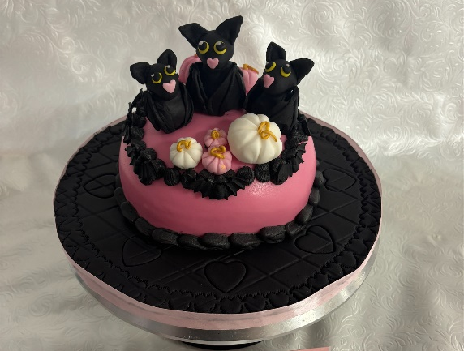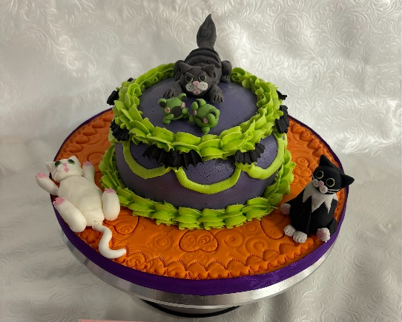

HE CAKE CRAFT SNEAK PEEK
Cost: Free
Trip Leader: HE Department
Maximum Number: 20 Pupils
Open to: All pupils with a good behaviour record
Details:
Come along and join Mrs Sinclair and Miss Sullivan, to develop your cake baking and decorating skills. An intense full-day session of baking, covering and decorating a cake with sugar paste. An opportunity to channel your Braes Creativity and come up with your own unique design.
The opportunity will allow you to develop:
- Baking skills
- Working with sugar paste to cover a cake
- Dexterity – creating models with sugar paste
- Piping skills

For more details see HE Department.



A DAY AT THE MOVIES
Cost: Free
Maximum Number: 40 Pupils
Open to: All pupils with a good behaviour record
Details:
Would you like an opportunity to have a fun day in school watching your favourite movies? Sign-up and come along for a movie day with your own snacks!

For more details see Mr B Smith.



FOOTBALL
Cost: FREE
Trip Leader: Mr D Yeates / Mr Ironside
Open to: All pupils with a good behaviour record
Details: What better than playing football all day? Pupils will have the chance to play indoor/outdoor 5 asides at the school, depending on the weather and player numbers. You will develop your skills, team working and be challenged through a range of games.
Pupils will have the usual school day breaks and can either leave the building for lunch or bring a packed lunch with them.
Pupils will be able to rotate physical/sporting activities during the second half of the day.

For more details see Mr B Smith.



RUGBY
Cost: FREE
Trip Leader: Mr R Ledger
Open to: All pupils with a good behaviour record
Details: What better than playing Rugby all day? Pupils will have the chance to play indoor/outdoor Rugby at the school, depending on the weather and player numbers. You will develop your skills, team working and be challenged through a range of games.
Pupils will have the usual school day breaks and can either leave the building for lunch, or bring a packed lunch with them.

Pupils will be able to rotate physical/sporting activities during the second half of the day.

For more details see Mr B Smith.



BASKETBALL
Cost: FREE
Trip Leader: Mrs G Bear
Open to: All pupils with a good behaviour record
Details: Fancy a full day of playing Basketball, training and building your skills & confidence through competition?
Pupils will be playing indoors at the school on the day, so please come prepared with appropriate indoor kit.
Pupils will have the usual school day breaks and can either leave the building for lunch or bring a packed lunch with them.
Pupils will be able to rotate physical/sporting activities during the second half of the day.

For more details see Mr S Docherty.



SWIMMING
Cost: FREE
Trip Leader: Mrs A Kidd
Open to: All pupils with a good behaviour record
Details: Fancy a half day of Swimming fun, with games and activities to keep you entertained.
Pupils will be in the Swimming pool, so should come prepared with appropriate kit and towel etc.
Pupils will have the usual school day breaks and can either leave the building for lunch or bring a packed lunch with them.
Pupils will be able to rotate physical/sporting activities during the second half of the day.

For more details see Mrs A Kidd.



WALKING
Cost: FREE
Trip Leader: Varied
Open to: All pupils with a good behaviour record
Details:
Take in a leisurely stroll with friends around the Braes area. Dependant on weather, we may venture further out with the school grounds and take in the Braes area.
Pupils should ensure they bring appropriate clothing for the activity, along with any snacks and drinks for the duration of the activity.
Pupils will be able to rotate physical/sporting activities during the second half of the day.

For more details see Mr B Smith.

OPTIONS TO CHOOSE FROM
External Activities
Pleasure Beach Cost £65
Blair Drummond Safari Park Cost £20
Xtreme Karting Cost £45
Top Golf Cost £35
M&Ds Cost £30
Lost Shore Cost £45
Crossfit 1298 Gym Visit Cost £14
In-School Activities
Movie Making Cost – Free
Board Games Café Cost – Free
French Boules and Languages Badge Cost – Free
Crafty Corner Cost – Free
Media & Film Activity Cost – Free
Cake Decorating Cost – Free
A Day at the Movies Cost – Free
Football Cost – Free
Rugby Cost – Free
Basketball Cost – Free
Swimming Cost – Free
Walking Cost – Free

ACTIVITIES DAY RETURN FORM
- The google form will be sent out to complete on Wednesday the 1st of April 2026 at 5.30pm.
- The trips will be allocated on a first-come first-serve basis on the forms, unless otherwise stated above.
- You should select the activity you would most like to do, however completion of the form will not guarantee you a space on the activity, as places are limited on some trips.
- You may select another external activity as a reserve choice in case there is space on other activities.
- You will have until 5pm on Friday the 3rd of April to complete your choice form.
- Please be aware no spaces are confirmed until you receive an email from the school confirming your place on a trip.
- If you select an in-school activity, you will be asked to select a reserve activity on the google form.
- No payments should be made until you have email confirmation from the school office.
- Detailed payment information, if required, will be shared in your confirmation email.
- Payments will be collected via online payment (www.ipayimpact.co.uk); or by card, cash or cheque at the school office.
- All payments should be made by Friday the 8th of May.
- If payments are not submitted by this date, activity places will automatically be allocated to pupils on the reserve list.
- Any queries regarding payment should be directed to the school office.

